**Preliminary training**

Original U_Net

Parameters:

* num_classes = 21
* input_size = (512, 512, 3)
* optimizer = "adam"
* learning_rate = 1e-3
* epochs = 10
* steps_per_epoch = 250
* validation_steps = 100
* batch_size = 4

Training Plots:

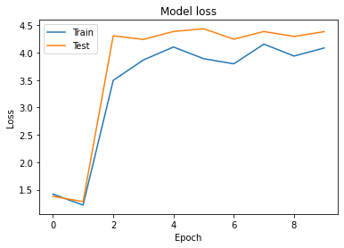

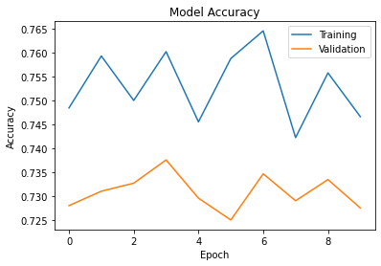

Prediction on a test image:

